EASTSHORE AMBULANCE
AUXILIARY SOCIETY
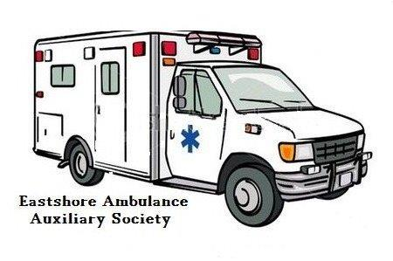

ANNUAL GENERAL MEETING
SATURDAY, April 15, 2017
10:00 am
Riondel Ambulance Hall

All those from the Eastshore Ambulance Service
Area are Invited to Attend
Coffee and Cookies will be Available

